CORS Issue Fix Steps

Results First 😊

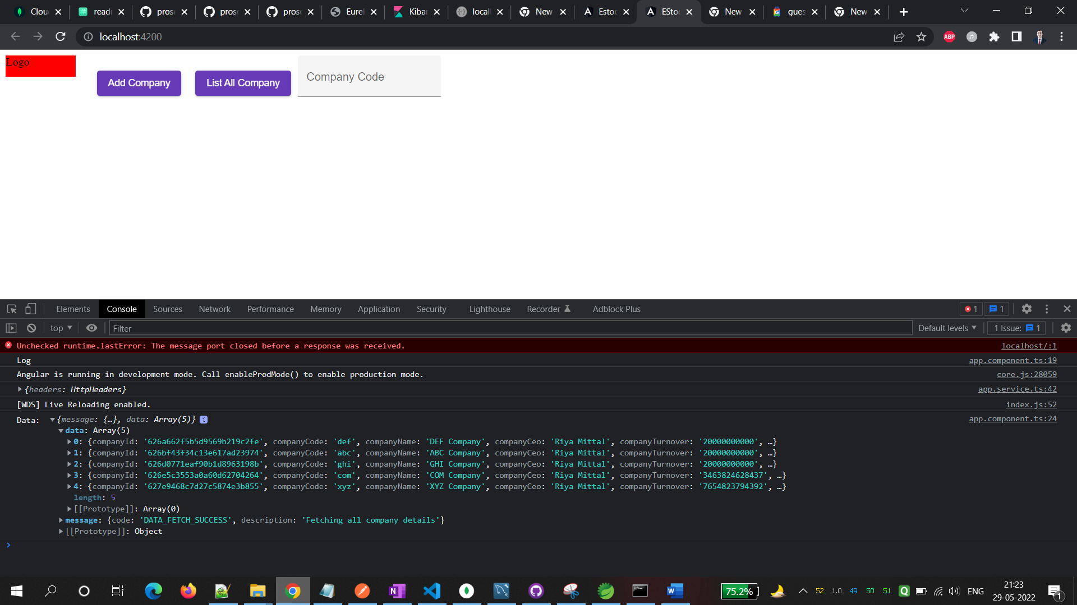

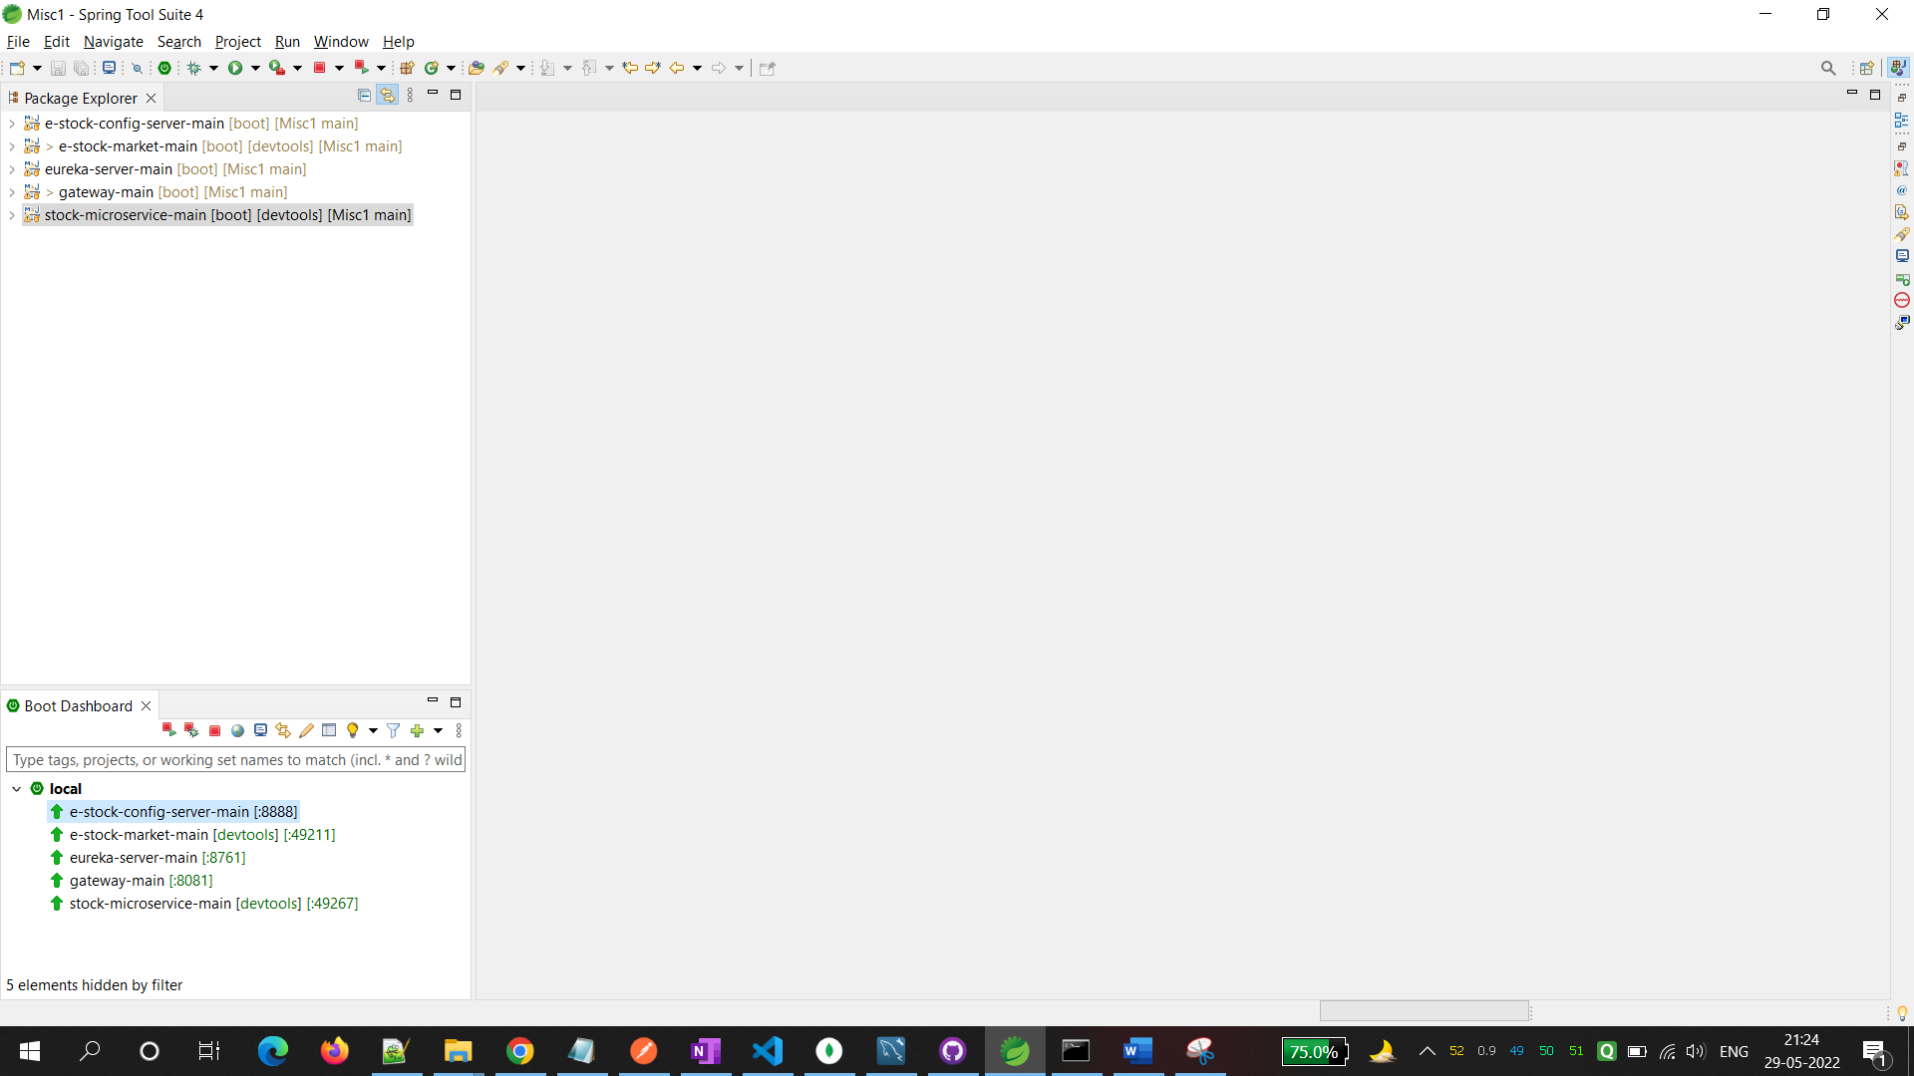

Steps Followed:

Total 5 changes:

Change 1: Delete CorsConfig.java from the project “e-stock-market-main”

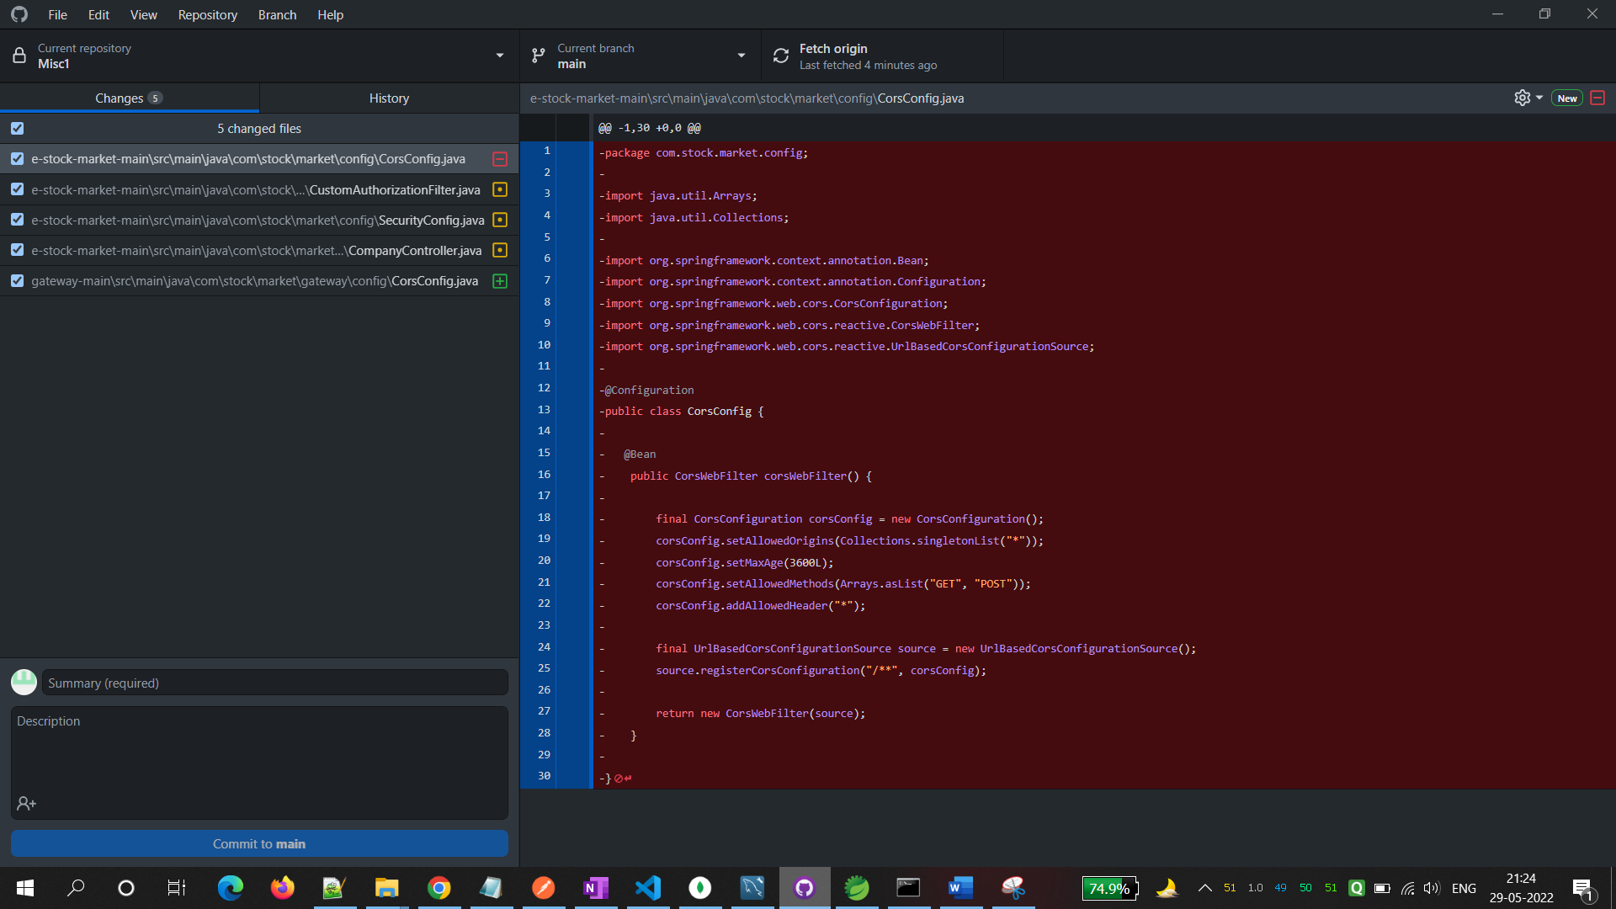

Change 2: Add CorsConfig.java in the project “gateway- main”

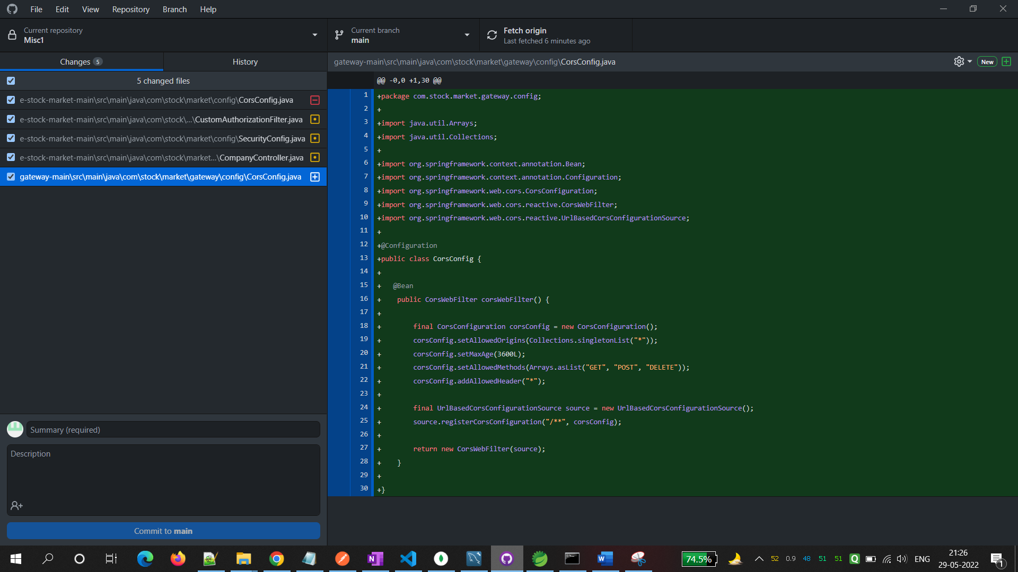

Change 3: Comment the below lines:

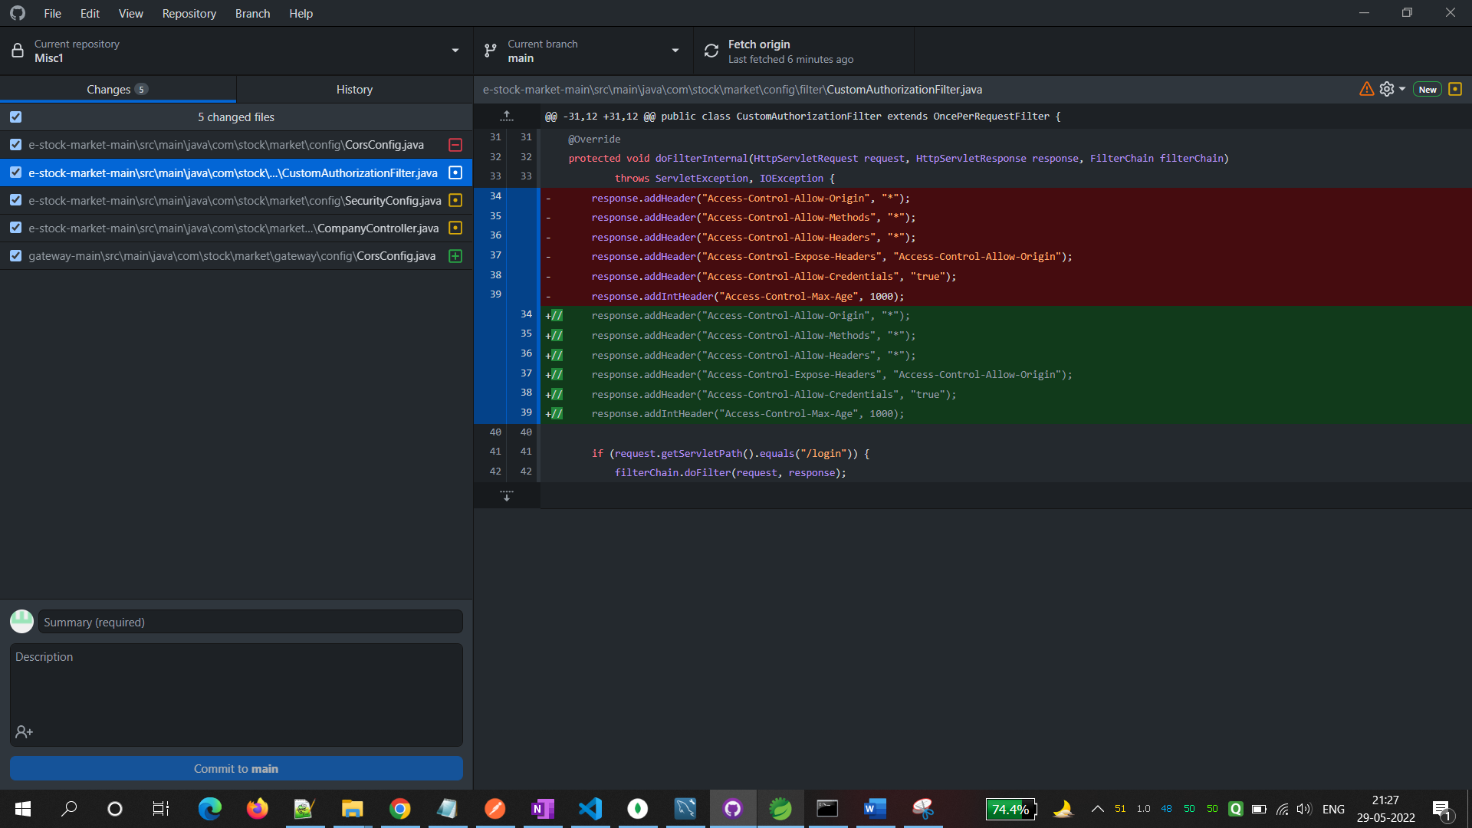

Change 4: Comment the below code

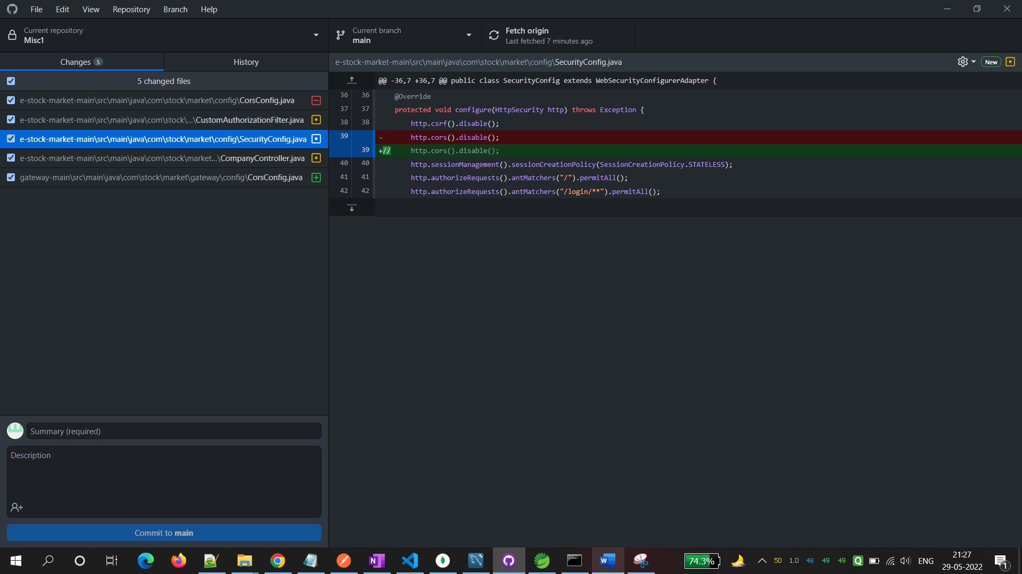

Change 5: Comment the below code.

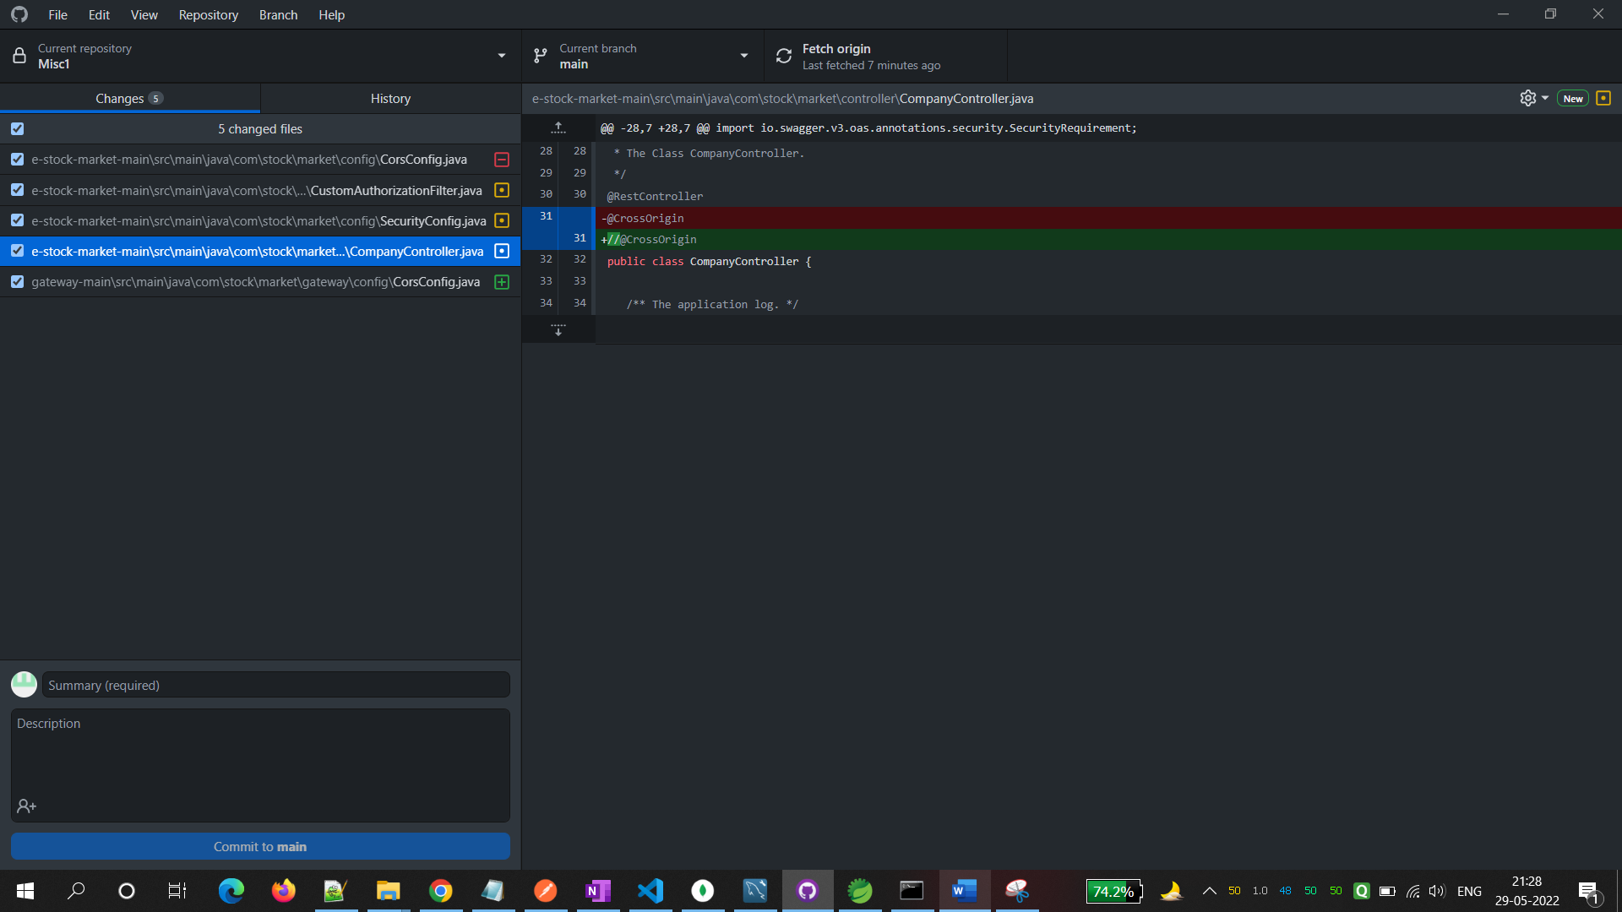

Done!

Happy Coding!